RFE—Recursive Feature Elimination
Regression: The number of features to be selected is K value. While selecting 9 features it gives better result in Decision tree and Randomforest.
- K=6
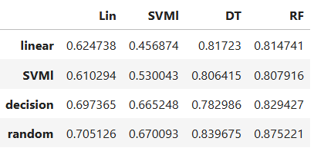

- K=5
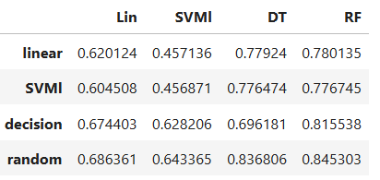

- K=9
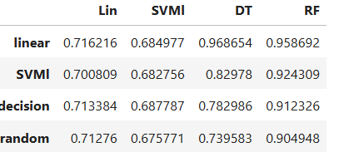

Classification: Both 3 nd 5 features selection gives good result. While k=5 is best.
- K=3
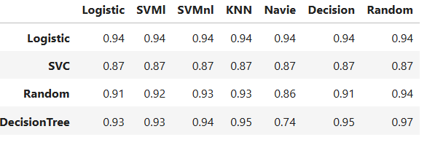
- K=5
